**Adult Skating Program**

|  |  |  |  |
| --- | --- | --- | --- |
| **Adult’s ( 18 +) can learn to skate in our Adult Learn to Skate Program. The program is suitable for adults with little or no skating abilities and also for competent skaters looking to improve their skating skills.**  **What do you need to participate?**  **All you need is skates and a CSA- Approved hockey helmet.** | | | |
| Day | Time | Rink | Cost |
| Thursday | 7:10-7:50 | Dartmouth 4PAD | $180 |

**SESSION DATES**

|  |
| --- |
| **Sept. 13,20,27**  **Oct. 4,11,18,25**  **Nov. 1,8,15,29**  **Dec. 13** |
|  |

APPLICATION FORM 2018 Fall Skating

Please print

|  |
| --- |
| **DSC Member in 2018 Spring/Summer season Yes __ No___**  Skater’s Name ______________________________________Gender __________  Mailing Address _____________________________________________________  City _______________________________ Postal Code _____________________  Email Address ______________________________________________________  Telephone # (H)__________________  Birth date: Day______ Mo______ Yr _______  Third immediate family member in a recreation program is ½ the lowest price. |

**PAYMENT:** Payment may be made with a cheque or cash. Cheque is made payable to the Dartmouth Skating Club.

All Skaters are required to pay the yearly $36.00 Skate Canada Registration/Insurance Fee, Membership is valid from September of 2018 until August of 2019.

Please circle if you are paying with cheque or cash.

Cheques are to be dated August 30th

Total Amount Paid ( $216.00 )______________________

Note: The club will not be responsible for personal injury or loss of property. A $35 fee will be charged on all NSF cheques. Program fees will be refunded on a prorated basis (less 25% administration fee) for **medical reasons only**. All requests for medical refunds must be made in writing and accompanied by a medical note to Kyla McNeil Upton @ kyla.upton.dsc@gmail.com

DSC reserves the right to cancel or modify any session due to insufficient enrollment. Fees must be paid in full prior to skater stepping on the ice.

**No refunds for snow days**

**I agree to allow the DSC to take pictures to be used on the DSC website: yes ___ no ____**

Signature: __________________ Date: _______________

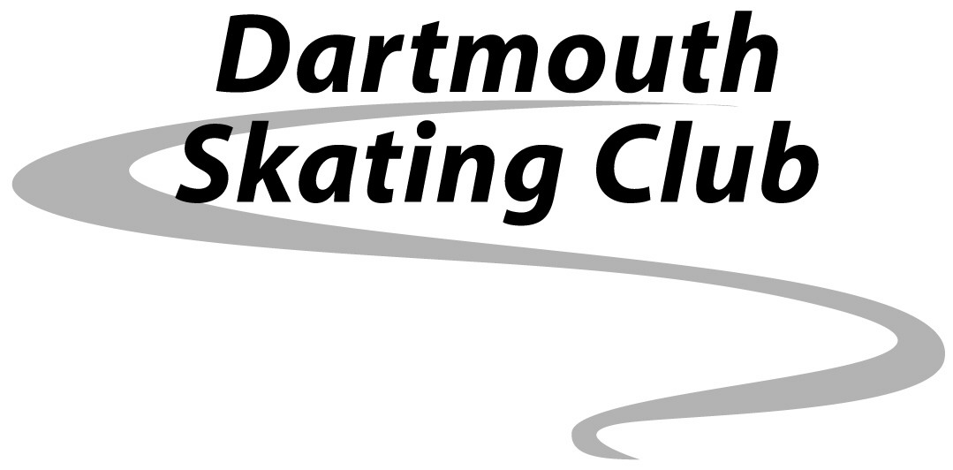

**Dartmouth 4PAD**

**MCj02153060000[1]**

**Fall Adult Skating**

**2018**

Mail Applications and Payment to:

Kyla McNeil Upton

11 Bligh Street

Dartmouth NS

B3A 1K8

[Kyla.upton.dsc@gmail.com](mailto:Kyla.upton.dsc@gmail.com)

[**www.dartmouthskatingclub.ca**](http://www.dartmouthskatingclub.ca)

**Join us on Facebook**

