|  |
| --- |
|  |

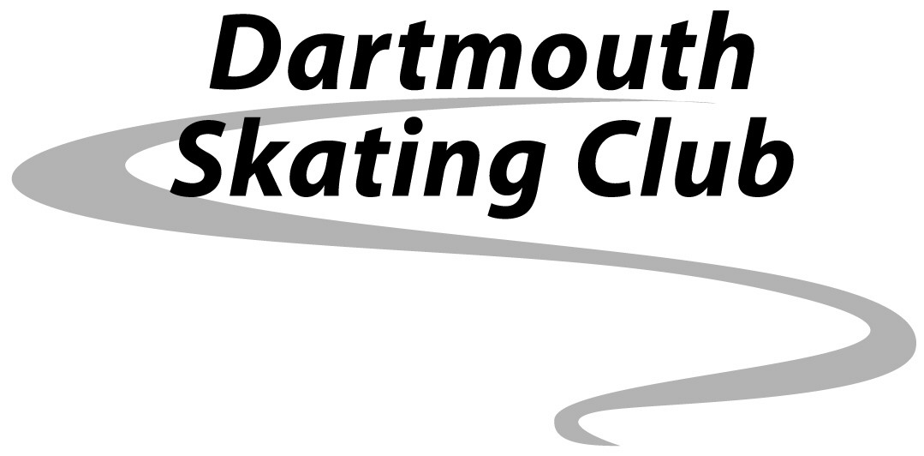

Fall 2017

Senior

Intermediate

Junior

MCj04125280000[1]

|  |
| --- |
| **Mail applications and payment to:**  **Kyla McNeil Upton**  **Dartmouth Skating Club**  **11 Bligh Street**  **Dartmouth NS  B3A 1K8** |
|  |

**Visit us at** [www.dartmouthskatingclub.ca](http://www.dartmouthskatingclub.ca) **(835-2012)**

General Information

* **Member Registration starts Sept. 1st by mail.**
* ***Members have priority placement until Sept. 8th***
* ***All registration must be in by Sept. 10th to avoid a late fee charge of $25.00***
* Cheques must be made payable to Dartmouth Skating Club (DSC).
* All skaters are required to become members of Skate Canada in the fall of each year, if you are not already a member, please add the fee of $36.00 to your total ice purchase. This fee is non-refundable.
* Program fees will be refunded on a prorated basis (less a %25 administration fee) and only if medical reasons exist. All refund requests must be in writing to the club within two weeks of absence.
* A $35 fee will be charged on all NSF cheques.
* The DSC reserves the right to add, delete or modify sessions depending on registration.
* Buy-Ins, $25 per hour for DSC Home Club Members and $30 for non- members.
* Ticket ice – when available; is open to those skaters who buy a minimum of 3 days per week in Jr. and 4 days per week in Inter and Sr.
* Adults are welcome on open sessions and Sr. Sessions with less than 13 skaters and approval of the Program Manager
* The club will not be responsible for personal injury or loss of property.
* Fees must be paid fully in accordance with registration requirements outlined on the application form prior to the skater stepping on the ice

**Please note**: Prices are set based on the estimated number of skaters divided by the cost of the session, along with some subsidy from the club. If you have any questions, please contact Helen Dawe-Webb at [hwebb@blazemarketing.ns.ca](mailto:hwebb@blazemarketing.ns.ca)

Dartmouth Skating Club

Fundraising 2017

|  |  |
| --- | --- |
| Event | Details |
| SportSweep Tickets | **All registered DSC Home Club Junior, Intermediate and Senior Skaters must participate in the DSC Fundraising Activities each year. During the 2017-2018 season, all figure skaters will be selling SportSweep tickets. Junior, Intermediate and Senior Skaters will each be receiving 5 books of tickets (50 tickets) to sell during the Fall Season. Details and tickets will be available in late September. Please note all funds raised will go directly to the operating costs of DSC. For each ticket sold, DSC receives $1.50.Should you wish not to sell the tickets and would prefer to support the DSC fundraising through a cash donation, you may opt out of selling tickets and provide a $75 donation at time of registration. All tickets must be sold and monies returned by December 15, 2017.** |
| Halloween Skate-A-Thon | Sunday October 29th  CHP  5:00-6:00 |
| Holiday Ice Show | Sunday December 17th  CHP  5:00-7:00 |



Fall 2017

APPLICATION FORM

|  |  |
| --- | --- |
| **First Name:** | **Last Name:** |
| **Address:** | **Parents Name:** |
| **DOB:** | **Phone Number/s:** |
| **Email:** | |
| **Highest Freeskate: Skate Canada #** | |
| **Coach: Coach Email-** | |

Waiver: The applicant does not hold the Dartmouth Skating Club responsible for injury or loss of personal effects while skating with the Dartmouth Skating Club.

Parent/s Signature: _____________________________________________________________________________________________

|  |  |  |
| --- | --- | --- |
| Session | Day | Price |
|  |  |  |
|  |  |  |
|  |  |  |
|  |  |  |
|  |  |  |
|  |  |  |
| Skate Canada Fee $36.00 | | |
| Total | | |

**Cheques**

|  |  |  |
| --- | --- | --- |
| Cheque #1 – Sept.14th  #_____________________ | Cheque #2 – Oct. 19th ( If buying 3 or more days)  #________________________ | Cheque #3 – Dec. 1st (If buying 3 or more days)  #_____________________ |

* **I agree to allow the DSC to take pictures of my child to be used on the DSC website**

**YES**□ **NO**□ Parent Signature_____________________________________________

* **Full payment is required with your application form. Payment may be made in three equal payments dated as noted above if buying more than 3 days.**
* **Cheques are to be made payable to the Dartmouth Skating Club.**
* **Please mail completed application and payment to – Dartmouth Skating Club- 11 Bligh St. Dartmouth NS B3A 1K8**

**The Dartmouth Skating Club reserves the right to add, delete or modify sessions depending on registration.**